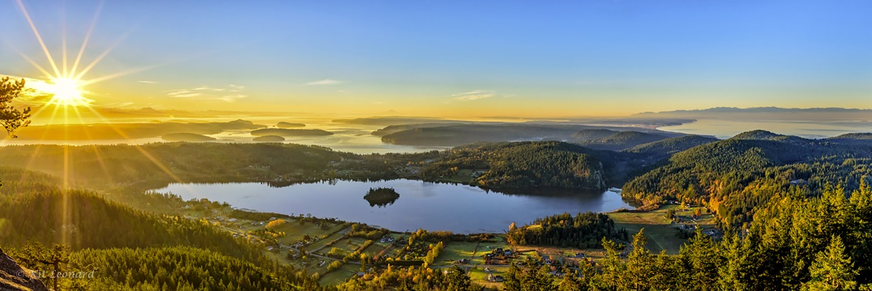

SKAGIT VALLEY CAMERA CLUB • • • MEMBERSHIP APPLICATION
www.skagitvalleycameraclub.org

Please Type or Print Clearly

Date:

Name(s): ____________________________________________

____________________________________________

Street Address:

Town: State/Zip:

Email: Phone:

(Please note this information is not made available outside the club.)

Membership Type: Individual ($30) Family ($40)

Paid with: Cash Check
(payable to SVCC)

SVCC operates on a calendar year, so dues are due on Jan. 1st of each year. Dues are prorated for those who join after June 30.

Please give your membership application and payment to our Treasurer or mail it to:
Skagit Valley Camera Club
P.O. Box 752
Anacortes, WA 98221

Payment of dues entitles you to attend monthly SVCC meetings and to participate in SVCC's monthly image sharing, the member galleries on SVCC's website, club art shows and other club activities.
Photo Credit: Kit Leonard
NEW MEMBER PROFILE

Name(s):

What Types of Things Do You Like to Photograph? (List as many as you want)
(for example, landscapes, wildlife, macro, portraits, abstracts)

What Is Your Level of Expertise?
Beginner Intermediate Expert Pro

What Are Your Principal Photo Editing Software Tools, If Any?
(for example, Lightroom, Photoshop, Nik Collection, Topaz, On1, DxO)

What Photographic Subjects Would You Like to Learn More About, If Any?
(for example, printing, black & white, night photography, long exposure, macro, post-processing in general, specific software programs-please specify)

What Would You Like from Your Camera Club? (mark all that apply)
____ Monthly image-sharing opportunity
____ Opportunities to Make Longer Presentations of a Body of Photographic Work
____ Photo challenges (such as contests or scavenger hunts)
____ Camaraderie and social time (not focused on photography)
____ Educational Programs
____ Opportunities to Receive Feedback / Analysis / Critique
____ Field trips or casual meetups to get together to do photography
____ Other (please specify:________________________________
__________________________________________________)

